**SQL Queries Answers**

iv) Write SQL Queries for following scenarios.(Create a text file and add queries and results)

1. Get all the information of all Students

SELECT * FROM Students;

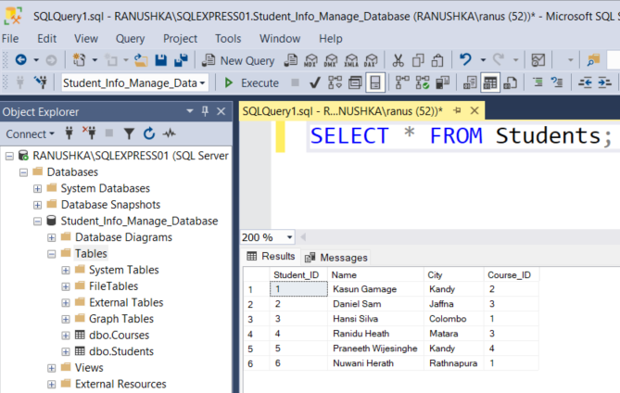

1. Select student id, name and city from students who are from the ‘kandy’.

SELECT Student_ID, Name, City FROM Students WHERE City= 'Kandy';

1. Update the City as 'Galle' of the student whose id equals to 4 .

UPDATE Students SET City='Galle'WHERE Course_ID=4;

1. Get all the information of all students with their course names.

SELECT Students.*, (SELECT Name FROM Courses WHERE Courses.Course_ID=Students.Course_ID) AS CourseName FROM Students;

